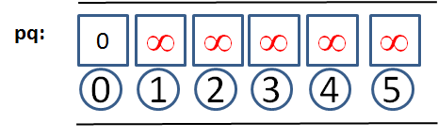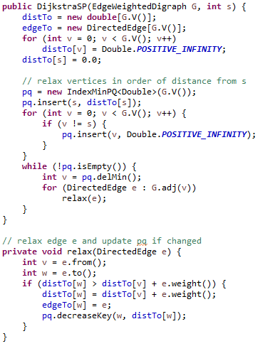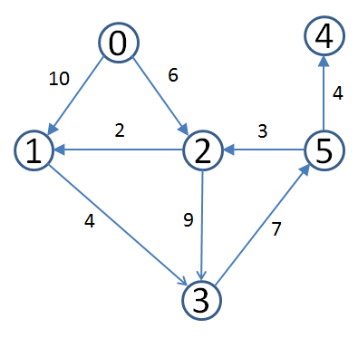 Starting Priority Queue. Yes it is a  
 Heap but you should represent as  
 a Min priority queue

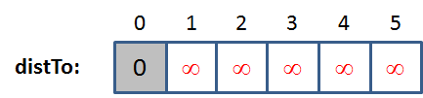 Distances are precomputed also

Operates by removing **min vertex**  
 from the priority queue (0 to start).

There are two opportunities to relax  
 an edge: (0,1) and (0,2). Once done,   
 state is as follows:

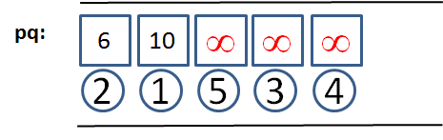

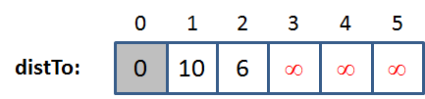

You should be able to continue this  
 execution until there are no more  
 edges to relax.